PIZZA SALES SQL QUERIES
A. KPI’s

- Total Revenue:
SELECT SUM(total_price) as Total_Revenue FROM pizza_sales;
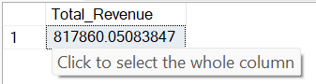

- Average Order Value:
SELECT SUM(total_price) / COUNT(DISTINCT order_id) AS Avg_order_value FROM pizza_sales
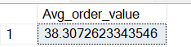

- Total Pizzas Sold:
SELECT SUM(quantity) AS Total_Pizza_Sold FROM pizza_sales
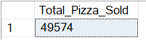

- Total Orders:
SELECT COUNT(DISTINCT order_id) AS Total_Order FROM pizza_sales
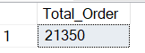

- Average Pizzas Per Order:
SELECT CAST(CAST(SUM(quantity) AS DECIMAL(10,2)) /
CAST(COUNT(DISTINCT order_id) AS DECIMAL(10,2)) AS DECIMAL (10,2))
AS Avg_Pizza_Order FROM pizza_sales
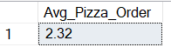

B. Daily Trend for Total Orders
SELECT DATENAME(DW, order_date) as Order_Day, COUNT(DISTINCT order_id) as Total_Orders
from pizza_sales
GROUP BY DATENAME(DW, order_date)
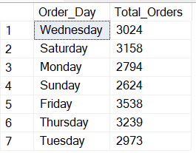
C. Hourly Trend for Orders
SELECT DATEPART(HOUR, order_time) as order_hours, COUNT(DISTINCT order_id) as Total_Orders
FROM pizza_sales
GROUP BY DATEPART(HOUR, order_time)
ORDER BY DATEPART(HOUR, order_time)
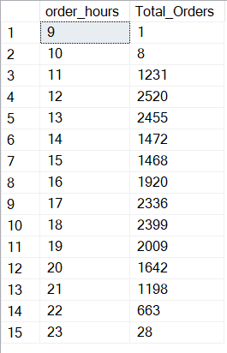

D. % of Sales by Pizza Category
SELECT pizza_category, SUM(total_price) AS Total_Sales, SUM(total_price) * 100 / (SELECT SUM(total_price) FROM pizza_sales WHERE MONTH(order_date) = 1) AS PCT
FROM pizza_sales
WHERE MONTH(order_date) = 1
GROUP BY pizza_category
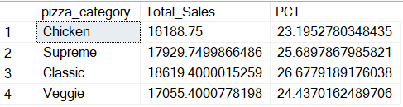

E. % of Sales by Pizza Size
SELECT pizza_size, CAST(SUM(total_price) AS DECIMAL(10,2)) AS Total_Sales, CAST(SUM(total_price) * 100 /
(SELECT SUM(total_price) FROM pizza_sales WHERE DATEPART(QUARTER, order_date) = 1) AS DECIMAL(10,2)) AS PCT
FROM pizza_sales
WHERE DATEPART(QUARTER, order_date) = 1
GROUP BY pizza_size
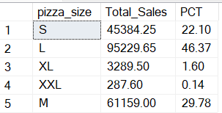

F. Total Pizzas Sold by Pizza Category
SELECT pizza_category, CAST(SUM(total_price) AS decimal(10,2)) AS Total_Sales, SUM(quantity) AS Total_Pizza_sold
FROM pizza_sales
GROUP BY pizza_category
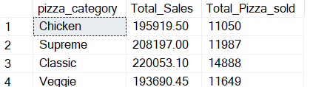

G. Top 5 Best Sellers by Total Pizzas Sold
SELECT TOP 5 pizza_name, SUM(quantity) AS Total_Pizza_Sold
FROM pizza_sales
GROUP BY pizza_name
ORDER BY SUM(quantity) DESC
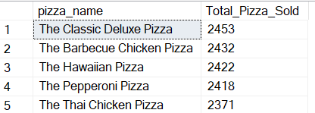
H. Bottom 5 Best Sellers by Total Pizzas Sold
SELECT TOP 5 pizza_name, SUM(quantity) AS Total_Pizza_Sold
FROM pizza_sales
WHERE MONTH(order_date) = 1
GROUP BY pizza_name
ORDER BY SUM(quantity)
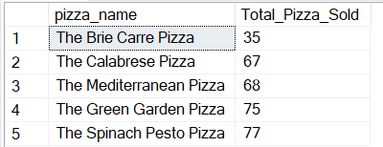

NOTE
If you want to apply the Month, Quarter, Week filters to the above queries you can use WHERE clause. Follow some of below examples
SELECT DATENAME(DW, order_date) AS order_day, COUNT(DISTINCT order_id) AS total_orders
FROM pizza_sales
WHERE MONTH(order_date) = 1
GROUP BY DATENAME(DW, order_date)

*Here MONTH(order_date) = 1 indicates that the output is for the month of January. MONTH(order_date) = 4 indicates output for Month of April.

SELECT DATENAME(DW, order_date) AS order_day, COUNT(DISTINCT order_id) AS total_orders
FROM pizza_sales
WHERE DATEPART(QUARTER, order_date) = 1
GROUP BY DATENAME(DW, order_date)

*Here DATEPART(QUARTER, order_date) = 1 indicates that the output is for the Quarter 1. MONTH(order_date) = 3 indicates output for Quarter 3.

